# **Breast Cancer regression using Logistic regression**

**Results**:

# **With random_state =1**

We split dataset into 25% for testing and 85% for training and we found these results after fitting on **Logistic regression algorithm:**

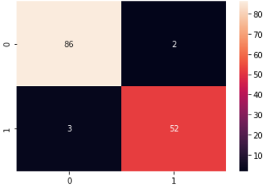

And the metrics results:

precision recall f1-score support

M 0.97 0.98 0.97 88

B 0.96 0.95 0.95 55

accuracy 0.97 143

macro avg 0.96 0.96 0.96 143

weighted avg 0.97 0.97 0.96 143

# **With random_state =42**

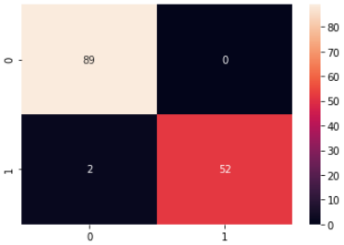

And confusion report Results:

precision recall f1-score support

M 0.98 1.00 0.99 89

B 1.00 0.96 0.98 54

accuracy 0.99 143

macro avg 0.99 0.98 0.99 143

weighted avg 0.99 0.99 0.99 143

we concluded that number of random state its very affected